June 2023

Dear Parents and Guardians of Grade 3 Students (2023 / 2024):

The following list indicates the basic supplies your child will need for grade three.

REQUIRED ITEMS:

- 8 – Duo-tangs (Green, Red, light Grey, Orange. Yellow, Blue, Black, Purple)
- 2 - Portfolio cover (twin pocket)
- 4 - Hilroy Redi-Tab Exercise Book (10 7/8" x 8 3/8") 40 pages
- 2 - Staedtler Norica HB #2 Pencils (pre-sharpened) - 12 pack
- 1 24 Pack - Crayola wax crayons
- 1 24 Pack - Pencil crayons
- 1 - 12 pack fine washable markers
- 2 – Permanent fin tip black Sharpie markers
- 1 – 4 Pack Expo low odor chisel tip markers
- 4 - Elmer's glue sticks - 22 g (77oz)
- 1 - White glue
- 1 - Bic Pen - red
- 1 - Highlighter
- 3 - White erasers
- 1 - Pair of blunt tip scissors
- 1 - Clear plastic ruler (measurements in cm/mm)
- 1 – 1” Binder
- 1 – 3 Ring Zippered Pencil Case
- 1 - Set of ear buds or headphones
- 1 - Carabiner Clip (or similar) for locker (Preferred style) 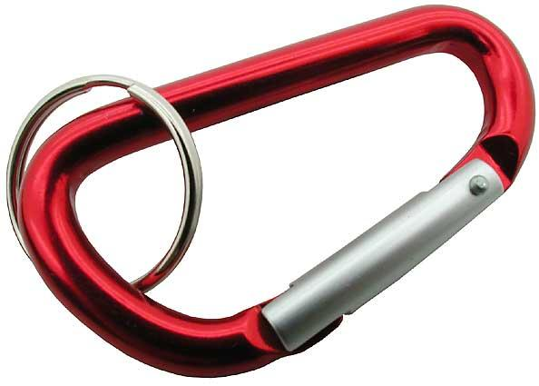
- 1 - Pair of indoor shoes (non-marking soles)

OPTIONAL ITEMS:

- 2 to 3 – Boxes of Kleenex
- 1 to 2 – Lysol wipe containers

MAKE SURE YOUR CHILD’S NAME is marked on ALL ITEMS. This includes clothing, as well as other articles and supplies that are brought from home.

Students need to have one pair of running shoes to wear inside the school and gym class (no black soles). Outdoor shoes are left in the boot room.

Thank you.
Grade Three Teachers

